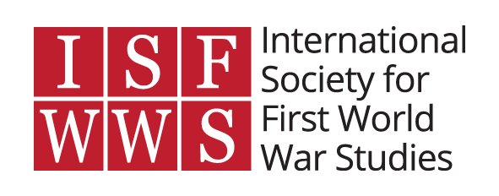
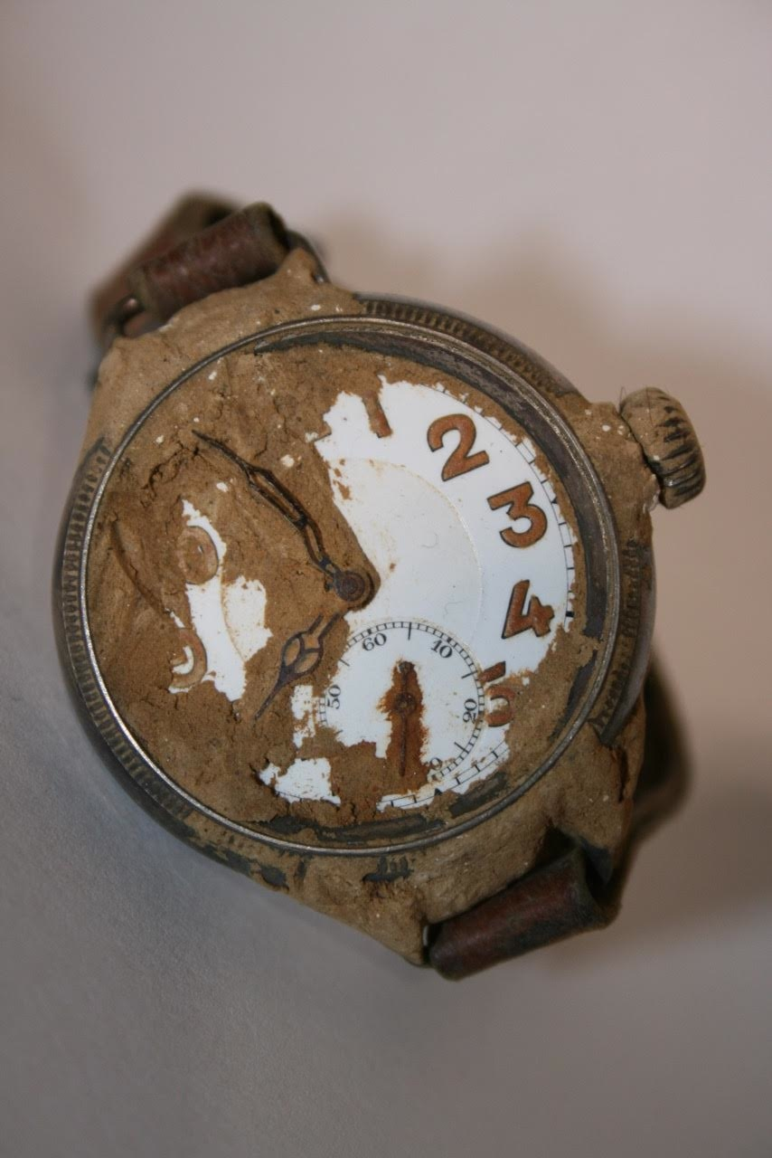

War Time 2016
9-11 November
Maison Française d’Oxford
#wartime16

9 November 2016
18:00 Wine reception, University of Oxford History Faculty (George Street)

10 November 2016 (Maison Française d’Oxford)
9:00 Registration and tea/coffee
9:25 Welcoming remarks
9:30 Keynote #1: “The long and the short of it: time and strategic planning in the First World War” (Hew Strachan, University of St. Andrews)
Chair: David Morgan-Owen (King’s College London)
10:30 Break
10:45 Panel 1: Aerial Time
Chair: Jack Doyle (University of Oxford)
- ‘It is at night-time that we notice most of the changes in our life caused by the war’: Zeppelins, Time and Space in Great War London (Assaf Mond, Tel Aviv University)
Commentator: John Horne (emeritus, Trinity College Dublin, Leverhulme Visiting Professor, Oxford)
- Privileged Deaths: Germany’s Living and Lost Aviators of the First World War (Robert Rennie, University of Tennessee – Knoxville)
Commentator: Michael Neiberg (United States Army War College)
11:45 Lunch
12:45 Keynote #2: “Time-frames of the Great War” (John Horne, TCD/Oxford)
Chair: Aimée Fox-Godden (King’s College London)
13:45 Panel 2: Endgame
Chair: Louis Halewood (University of Oxford)
- Timing on the Eastern Front: The wartime experience in the Ottoman World (Thomas Schmutz, University of Newcastle [Australia])
Commentator: Hew Strachan (University of St. Andrews)
- That sinking feeling: The U-Boot Option and German Conceptions of Victory in the First World War (Marc-André Dufour, University of Toronto)
Commentator: Nicholas Rodger (University of Oxford)
14:45 Break
15:00 Panel 3: Medical Time
Chair: Adam Luptak (University of Oxford)
- The time of therapy: the Italian military psychiatry and the control of time and space (Anna Grillini)
Commentator: Martina Salvante (University of Warwick)
- No time to waste: how German authorities attempted to speed up the healing process of soldiers in military hospitals, 1914-1918 (Alina Enzensberger, Humboldt University of Berlin)
Commentator: Heather Perry (University of North Carolina – Charlotte)
16:00 Break with tea/coffee
16:15 Panel 4: Soundscapes of Time
Chair: John Paul Newman (Maynooth University)
- Rhythms and Ruptures: Church Bells and the Dislocation of Time in the Habsburg Empire during the First World War (Claire Morelon, University of Oxford)
Commentator: Christoph Mick (University of Warwick)
- ‘Mechanical rhythms’: Music & Temporal Multiplicities in Pre-War Paris (Ellen Davies, University of Oxford)
Commentator: Kate Kennedy (University of Oxford)
17:15 Break
17:30 Panel 5: Ideological Timelines
Chair: Patrick Houlihan (University of Oxford)
- Between futurism and passatism: the rites of consecration to the Sacred Heart of Jesus in a transnational perspective (1914-1919) (Sante Lesti, University of Pisa)
Commentator: Selena Daly (University College Dublin)
- “Soul-stirring times”: Wartime, Global Disintegration and Japan’s Case for Teleology (Steffen Rimner, Leiden University)
Commentator: Jan Schmidt (KU Leuven)
18:30 Awarding of Oxford’s TORCH/Academic IT First World War competition winner and runner-up, and end of Day 1
19:15 Conference dinner at Zizzi (59 George Street)

11 November 2016 (Maison Française d’Oxford)
10:30 Tea/coffee, and registration for ‘Day 2 only’ attendees
11:00 Two-minute silence
11:02 Panel 6: Personal Memories and Experiences
Chair: Catriona Pennell (University of Exeter)
- The introduction of Daylight Saving Time during the First World War:
experiences in daily life with time change in Germany 1916 – 1918 (Felix Schmidt, Heidelberg University / EHESS Paris)
Commentator: Jenny Macleod (University of Hull)
- Age, Generations and the Life Cycle in Comradeship after the Great War (Ashley Garber, University of Oxford)
Commentator: Helen McCartney (King’s College London)
12:00 Break

12:15 Panel 7: Materiality on the Home Front
Chair: Calum White (University of Oxford)
- A Stitch in Time: Inefficiency and the Appeal of Patriotic Work in Australia and Canada (Steve Marti, University of Delaware) Commentator: Pierre Purseigle (University of Warwick)
- The Photo Albums of the 20th Century’s “Destructive Character”: the visual materiality of the First World War (Erica Grossi)
Commentator: Franziska Heimburger (Université Paris-Sorbonne)
13:15 Lunch
14:15 Panel 8: Discursive Time
Chair: Alice Kelly (University of Oxford)
- Time and Comic Absurdity in First World War Poetry (Emily Anderson, Newcastle University)
Commentator: Jane Potter (Oxford Brookes University)
- “La guerre continue, continue”: Apollinaire, Slow Time and the Trench Press (Cedric Van Dijck, Ghent University)
Commentator: Laurence Campa (Université Paris Ouest – Nanterre)
15:15 Break
15:30 Panel 9: Time at the front/Anticipation
Chair: Vanda Wilcox (John Cabot University)
- ‘Gentlemen- Synchronise Your Watches!’ The Wristwatch and the Temporal Order of World War I (Frank Reichherzer, Centre for Military History and Social Sciences – Potsdam)
Commentator: Jonathan Boff (University of Birmingham)
- Hopes of Peace: Morale and the Future on the Western Front, 1914-1918 (Alex Mayhew, London School of Economics and Political Science)
Commentator: Margaret MacMillan (University of Oxford)
16:30 Break with tea/coffee
16:45 Keynote #3: “Moving from War to Peace” (Margaret MacMillan, University of Oxford)
Chair: Jonathan Krause (University of Oxford)
17:45 Awarding of Gail Braybon Prize, closing remarks, and conference end

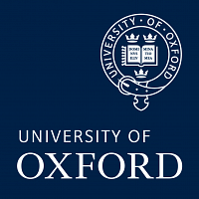

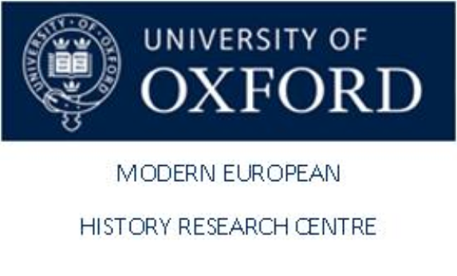
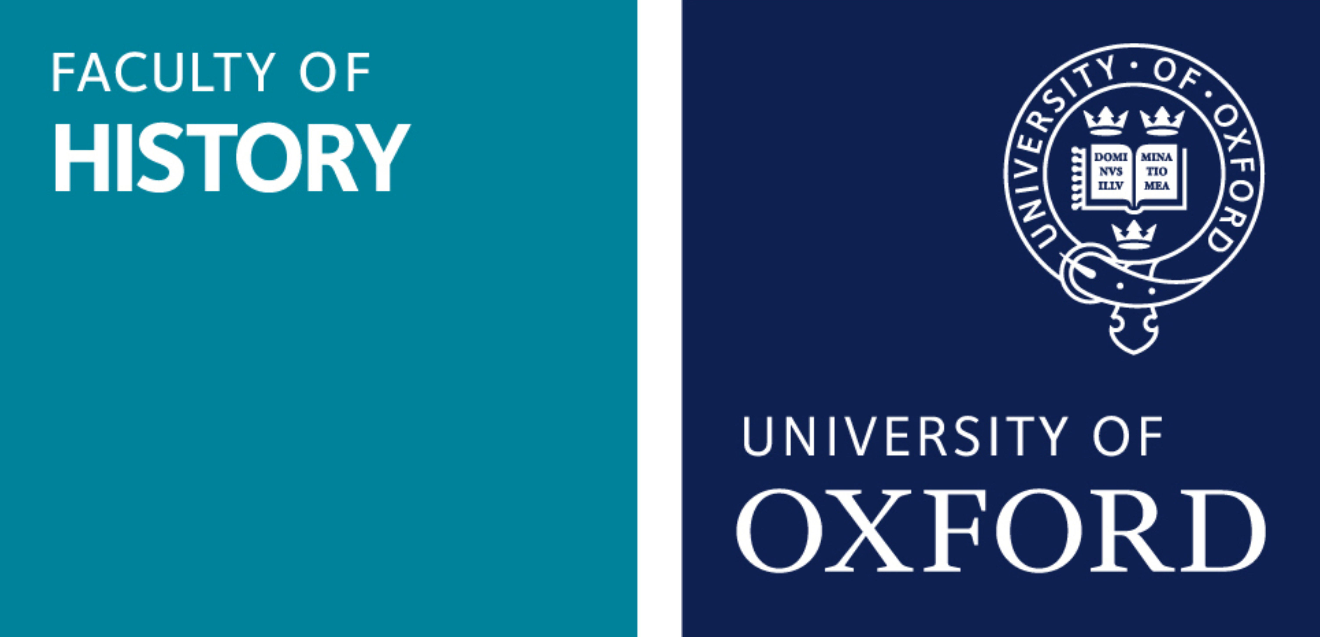

Conference logo image: Watch belonging to Harold Llewellyn Twite (1879-1915), which stopped at the moment of his death. “Twite, a St Agnes-born mining engineer, was posted to France in September 1915 and led a team of Cornish miners tunnelling under the German trenches to detonate explosives. On 1 December 1915, Twite and four of his fellow Cornishmen were blown up by a German mine. His watch stopped at that moment.” Credit: St Agnes Museum, used with permission.

